**Practice Question – 4**

**Streamlit with Multipage Dashboard**

03.09.2025

Consider the following code for Supermarket.xlsx dataset and create a multipage dashboard using streamlit:

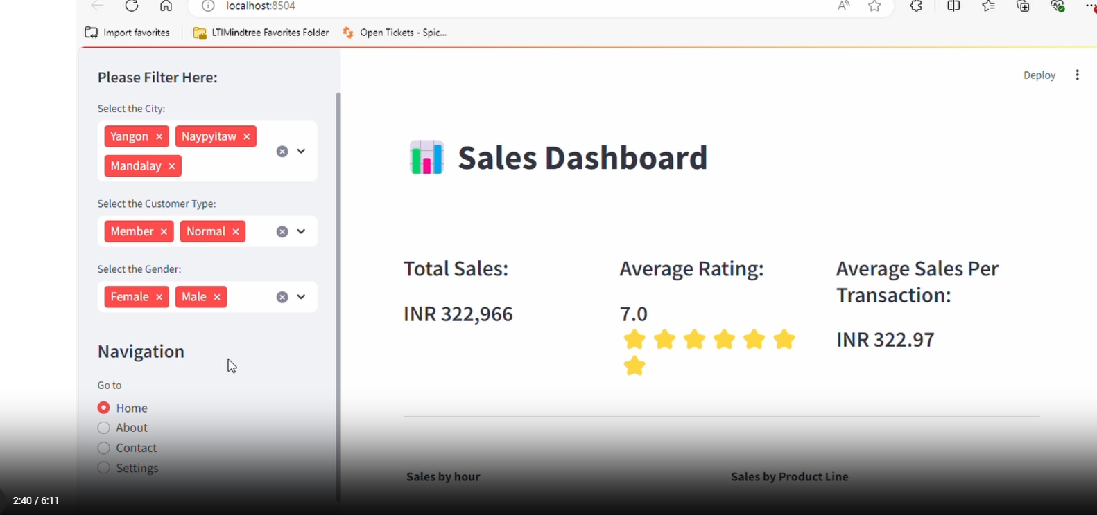

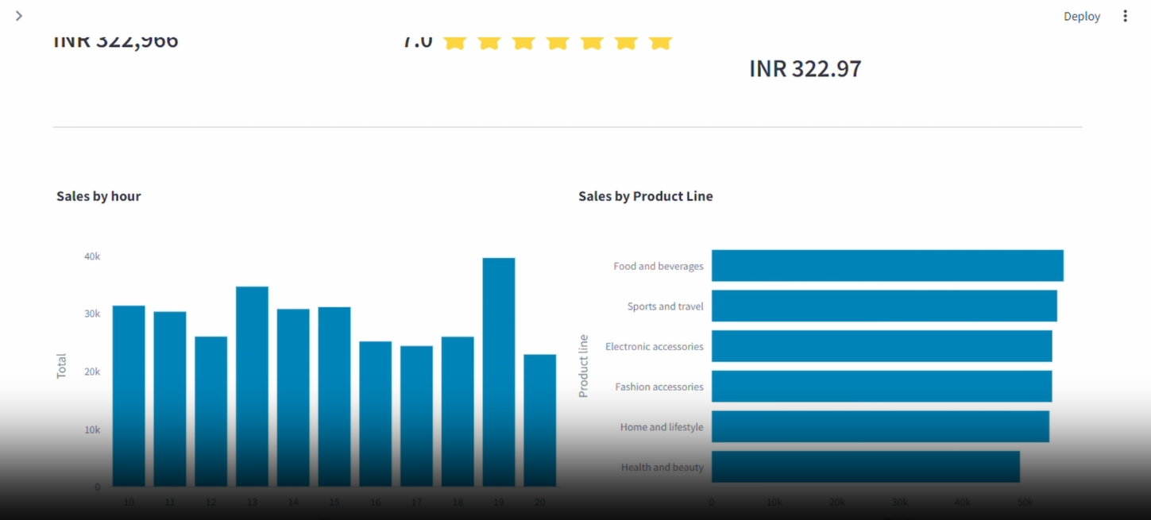

import pandas as pd

import plotly.express as px

import streamlit as st

# Set Streamlit page configuration

st.set_page_config(page_title="Sales Dashboard", page_icon=":bar_chart:", layout="wide")

# Function to load data from Excel

@st.cache(allow_output_mutation=True)

def get_data_from_excel():

try:

df = pd.read_excel(

io="supermarkt_sales.xlsx",

engine="openpyxl",

sheet_name="Sales",

skiprows=0, # Adjust skiprows if needed

nrows=100, # Adjust nrows if needed

)

# Check if 'Time' column exists in the dataframe

if 'Time' in df.columns:

df["Time"] = pd.to_datetime(df["Time"], format="%H:%M:%S").dt.time

else:

st.error("Error: 'Time' column not found in the Excel data.")

st.stop() # Stop execution if 'Time' column is missing

return df

except FileNotFoundError:

st.error("Error: File 'supermarkt_sales.xlsx' not found.")

st.stop() # Stop execution if file is not found

except Exception as e:

st.error(f"An error occurred: {str(e)}")

st.stop() # Stop execution for any other unexpected errors

# Load data from Excel

df = get_data_from_excel()

# Sidebar filters

st.sidebar.header("Please Filter Here:")

city = st.sidebar.multiselect(

"Select the City:",

options=df["City"].unique(),

default=df["City"].unique()

)

customer_type = st.sidebar.multiselect(

"Select the Customer Type:",

options=df["Customer type"].unique(),

default=df["Customer type"].unique(),

)

gender = st.sidebar.multiselect(

"Select the Gender:",

options=df["Gender"].unique(),

default=df["Gender"].unique()

)

st.sidebar.title("Navigation")

page = st.sidebar.radio("Go to", ["Home", "About", "Contact", "Settings"])

# Filter dataframe based on sidebar selections

# Ensure correct column names and string formatting in query

query_string = f"City == {city} and Customer type == {customer_type} and Gender == {gender}"

df_selection = df.query(query_string)

# Check if filtered dataframe is empty

if df_selection.empty:

st.warning("No data available based on the current filter settings!")

st.stop() # Stop execution if filtered dataframe is empty

# Main page content

st.title(":bar_chart: Sales Dashboard")

st.markdown("##")

# Top KPIs

total_sales = int(df_selection["Total"].sum())

average_rating = round(df_selection["Rating"].mean(), 1)

star_rating = ":star:" * int(round(average_rating, 0))

average_sale_by_transaction = round(df_selection["Total"].mean(), 2)

# Display top KPIs in columns

left_column, middle_column, right_column = st.columns(3)

with left_column:

st.subheader("Total Sales:")

st.subheader(f"INR {total_sales:,}")

with middle_column:

st.subheader("Average Rating:")

st.subheader(f"{average_rating} {star_rating}")

with right_column:

st.subheader("Average Sales Per Transaction:")

st.subheader(f"INR {average_sale_by_transaction}")

# Separator line

st.markdown("""---""")

# Sales by Product Line (Bar chart)

sales_by_product_line = df_selection.groupby(by=["Product line"])[["Total"]].sum().sort_values(by="Total")

fig_product_sales = px.bar(

sales_by_product_line,

x="Total",

y=sales_by_product_line.index,

orientation="h",

title="<b>Sales by Product Line</b>",

color_discrete_sequence=["#0083B8"] * len(sales_by_product_line),

template="plotly_white",

)

fig_product_sales.update_layout(

plot_bgcolor="rgba(0,0,0,0)",

xaxis=dict(showgrid=False)

)

# Sales by Hour (Bar chart)

sales_by_hour = df_selection.groupby(by=["Time"])[["Total"]].sum()

fig_hourly_sales = px.bar(

sales_by_hour,

x=sales_by_hour.index,

y="Total",

title="<b>Sales by Hour</b>",

color_discrete_sequence=["#0083B8"] * len(sales_by_hour),

template="plotly_white",

)

fig_hourly_sales.update_layout(

xaxis=dict(tickmode="linear"),

plot_bgcolor="rgba(0,0,0,0)",

yaxis=dict(showgrid=False),

)

# Display charts in two columns

left_column, right_column = st.columns(2)

left_column.plotly_chart(fig_hourly_sales, use_container_width=True)

right_column.plotly_chart(fig_product_sales, use_container_width=True)

# Hide Streamlit style (optional)

# hide_st_style = """

# <style>

# #MainMenu {visibility: hidden;}

# footer {visibility: hidden;}

# header {visibility: show;}

# </style>

# """

# st.markdown(hide_st_style, unsafe_allow_html=True)